**INTRODUCTION:**

MongoDB is an open source [NoSQL](https://www.techtarget.com/searchdatamanagement/definition/NoSQL-Not-Only-SQL) database management program. NoSQL (Not only SQL) is used as an alternative to traditional relational databases. NoSQL databases are quite useful for working with large sets of distributed data. MongoDB is a tool that can manage document-oriented information, store or retrieve information.

MongoDB is used for high-volume data storage, helping organizations store large amounts of data while still performing rapidly. Organizations also use MongoDB for its ad-hoc queries, indexing, [load balancing](https://www.techtarget.com/searchnetworking/definition/load-balancing), aggregation, server-side JavaScript execution and other features.

Structured Query Language ([SQL](https://www.techtarget.com/searchdatamanagement/definition/SQL)) is a standardized programming language that is used to manage relational databases.

## **How does MongoDB work?**

MongoDB environments provide users with a server to create databases with MongoDB. MongoDB stores data as records that are made up of collections and documents.

Documents contain the data the user wants to store in the MongoDB database. Documents are composed of field and value pairs. They are the basic unit of data in MongoDB. The documents are similar to [JavaScript Object Notation](https://www.theserverside.com/definition/JSON-Javascript-Object-Notation) (JSON) but use a variant called Binary JSON (BSON). The benefit of using BSON is that it accommodates more data types. The fields in these documents are like the columns in a relational database. Values contained can be a variety of data types, including other documents, arrays and arrays of documents, according to the MongoDB user manual.

## **Features of MongoDB:**

* **Replication.** A replica set is two or more MongoDB instances used to provide high availability. Replica sets are made of primary and secondary servers. The primary MongoDB server performs all the read and write operations, while the secondary replica keeps a copy of the data. If a primary replica fails, the secondary replica is then used.
* **Scalability.** MongoDB supports vertical and horizontal scaling. Vertical scaling works by adding more power to an existing machine, while horizontal scaling works by adding more machines to a user's resources.
* **Load balancing.** MongoDB handles load balancing without the need for a separate, dedicated load balancer, through either vertical or horizontal scaling.
* **Schema-less.** MongoDB is a schema-less database, which means the database can manage data without the need for a blueprint.

# **MongoDB Datatypes:**

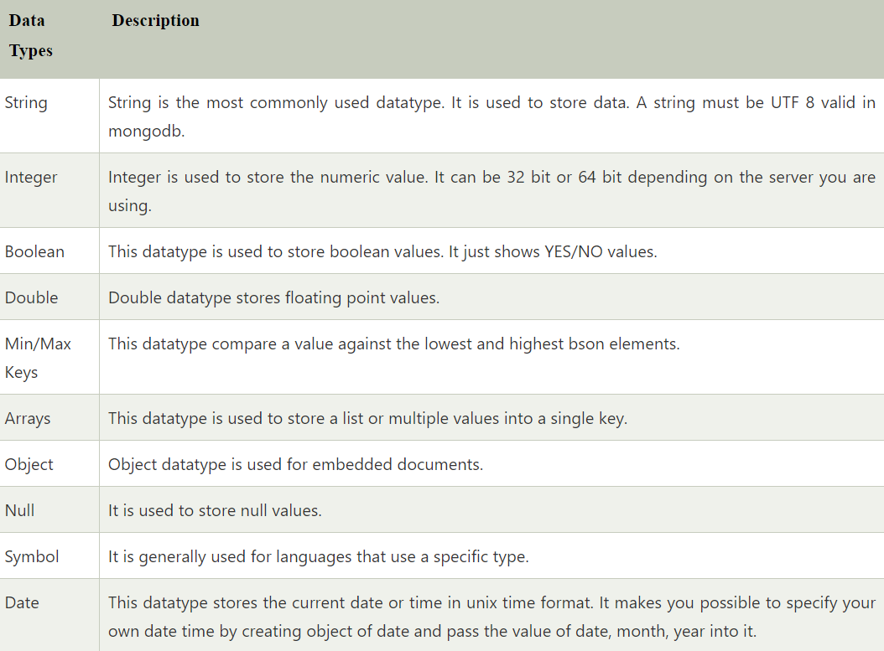

# MongoDB limit() Method:

In MongoDB, limit() method is used to limit the fields of document that you want to show. Sometimes, you have a lot of fields in collection of your database and have to retrieve only 1 or 2. In such case, limit() method is used.

**Syntax:**

1. db.COLLECTION_NAME.find().limit(NUMBER)

## Example

1. db.find().limit(1)

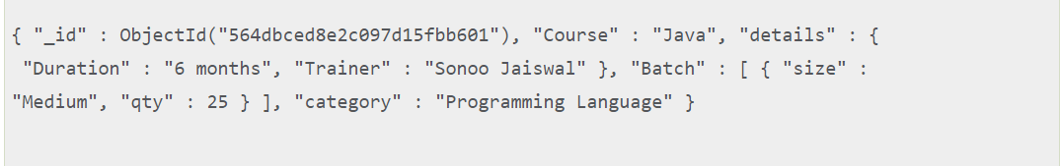

# MongoDB sort() method:

MongoDB, sort() method is used to sort the documents in the collection. This method accepts a document containing list of fields along with their sorting order.

* 1 is used for ascending order sorting.
* -1 is used for descending order sorting.

**Syntax:**

1. db.COLLECTION_NAME.find().sort({**KEY**:1})

**DATABASE**

## The use Command

MongoDB **use DATABASE_NAME** is used to create database. The command will create a new database if it doesn't exist, otherwise it will return the existing database.

### Syntax

Basic syntax of **use DATABASE** statement is as follows −

use DATABASE_NAME

If you want to check your databases list, use the command **show dbs**.

>show dbs

local 0.78125GB

test 0.23012GB

## **The createCollection() Method**

MongoDB **db.createCollection(name, options)** is used to create collection.

### Syntax

Basic syntax of **createCollection()** command is as follows −

db.createCollection(name, options)

In the command, **name** is name of collection to be created. **Options** is a document and is used to specify configuration of collection.

| **Parameter** | **Type** | **Description** |
| --- | --- | --- |
| Name | String | Name of the collection to be created |
| Options | Document | (Optional) Specify options about memory size and indexing. |
|  |  |  |
|  |  |  |